Final Year B. Tech., Sem VII 2025-26

High Performance Computing Lab
Practical No. 7
Name: Jasmine Sayyad
PRN: 22510033
Batch: B8

Implement Matrix-Vector Multiplication using MPI. Use different number of processes and analyze the performance.
- #include <mpi.h>
- #include <stdio.h>
- #include <stdlib.h>

- int main(int argc, char** argv) {
- MPI_Init(&argc, &argv);

- int rank, size;
- MPI_Comm_rank(MPI_COMM_WORLD, &rank);
- MPI_Comm_size(MPI_COMM_WORLD, &size);

- int M = 6; // rows
- int N = 6; // cols

- int *matrix = NULL;
- int *vector = (int*)malloc(N * sizeof(int));
- int *local_matrix = (int*)malloc((M/size) * N * sizeof(int));
- int *local_result = (int*)malloc((M/size) * sizeof(int));
- int *result = NULL;

- // Rank 0 initializes matrix and vector
- if (rank == 0) {
- matrix = (int*)malloc(M * N * sizeof(int));
- result = (int*)malloc(M * sizeof(int));

- printf("Matrix A:\n");
- for (int i = 0; i < M; i++) {
- for (int j = 0; j < N; j++) {
- matrix[i*N + j] = i + j + 1; // simple values
- printf("%d ", matrix[i*N + j]);
- }
- printf("\n");
- }

- printf("Vector x:\n");
- for (int i = 0; i < N; i++) {
- vector[i] = i + 1;
- printf("%d ", vector[i]);
- }
- printf("\n");
- }

- // Broadcast vector to all processes
- MPI_Bcast(vector, N, MPI_INT, 0, MPI_COMM_WORLD);

- // Scatter rows of matrix among processes
- MPI_Scatter(matrix, (M/size)*N, MPI_INT,
- local_matrix, (M/size)*N, MPI_INT,
- 0, MPI_COMM_WORLD);

- // Each process computes its part of result
- for (int i = 0; i < M/size; i++) {
- local_result[i] = 0;
- for (int j = 0; j < N; j++) {
- local_result[i] += local_matrix[i*N + j] * vector[j];
- }
- }

- // Gather results back to root
- MPI_Gather(local_result, M/size, MPI_INT,
- result, M/size, MPI_INT,
- 0, MPI_COMM_WORLD);

- // Rank 0 prints final result
- if (rank == 0) {
- printf("Result vector y = A * x:\n");
- for (int i = 0; i < M; i++) {
- printf("%d ", result[i]);
- }
- printf("\n");
- }

- free(local_matrix);
- free(local_result);
- free(vector);
- if (rank == 0) {
- free(matrix);
- free(result);
- }

- MPI_Finalize();
- return 0;
- }

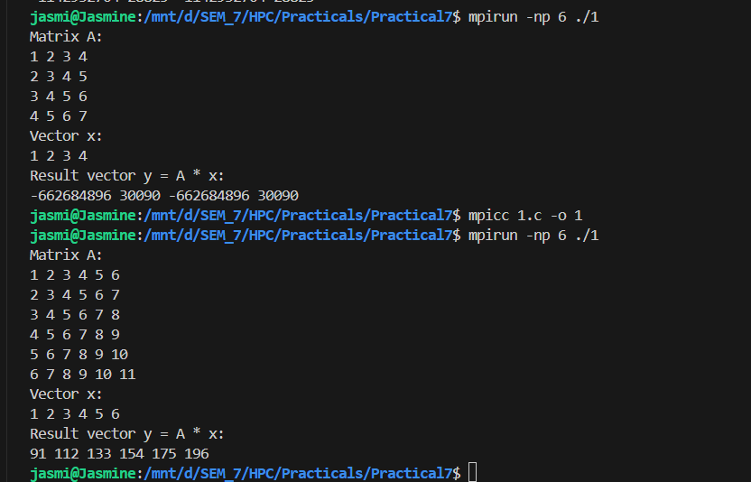

Implement Matrix-Matrix Multiplication using MPI. Use different number of processes and analyze the performance.
- #include <stdio.h>
- #include <stdlib.h>
- #include <mpi.h>

- int main(int argc, char* argv[]) {
- int n = 800; // matrix size (n x n), change for performance testing
- int rank, size;
- int *A, *B, *C;
- int *localA, *localC;

- MPI_Init(&argc, &argv);
- MPI_Comm_rank(MPI_COMM_WORLD, &rank);
- MPI_Comm_size(MPI_COMM_WORLD, &size);

- if (n % size != 0) {
- if (rank == 0) printf("Matrix size must be divisible by processes.\n");
- MPI_Finalize();
- return 0;
- }

- int rows = n / size;
- localA = (int*)malloc(rows * n * sizeof(int));
- localC = (int*)malloc(rows * n * sizeof(int));
- B = (int*)malloc(n * n * sizeof(int));

- if (rank == 0) {
- A = (int*)malloc(n * n * sizeof(int));
- C = (int*)malloc(n * n * sizeof(int));
- for (int i = 0; i < n * n; i++) {
- A[i] = 1; // simple values
- B[i] = 1; // all ones
- }
- }

- double start = MPI_Wtime();

- MPI_Scatter(A, rows * n, MPI_INT, localA, rows * n, MPI_INT, 0, MPI_COMM_WORLD);
- MPI_Bcast(B, n * n, MPI_INT, 0, MPI_COMM_WORLD);

- // compute local matrix multiplication
- for (int i = 0; i < rows; i++) {
- for (int j = 0; j < n; j++) {
- int sum = 0;
- for (int k = 0; k < n; k++) {
- sum += localA[i * n + k] * B[k * n + j];
- }
- localC[i * n + j] = sum;
- }
- }

- MPI_Gather(localC, rows * n, MPI_INT, C, rows * n, MPI_INT, 0, MPI_COMM_WORLD);

- double end = MPI_Wtime();
- double local_time = end - start;
- double max_time;

- MPI_Reduce(&local_time, &max_time, 1, MPI_DOUBLE, MPI_MAX, 0, MPI_COMM_WORLD);

- if (rank == 0) {
- printf("Matrix size: %d x %d\n", n, n);
- printf("Processes: %d\n", size);
- printf("Execution Time: %f seconds\n", max_time);

- }

- free(localA);
- free(localC);
- free(B);
- if (rank == 0) {
- free(A);
- free(C);
- }

- MPI_Finalize();
- return 0;
- }

Output:
